**Identifying biological markers for insulin resistance using high-throughput sequencing data (RNA-seq) from dermal endothelial cells to establish a safe diagnostic test**

*Varun Ullanat (varunullanat.bt17@rvce.edu.in)*

**1. Introduction**

With the emergence of RNA sequencing (RNA-seq) technologies, RNA-based biomolecules hold expanded promise for their diagnostic, prognostic and therapeutic applicability in various diseases, including cancers and infectious diseases. Detection of gene fusions and differential expression of known disease-causing transcripts by RNA-seq represent some of the most immediate opportunities. Here, I propose a novel diagnostic technique for insulin resistance (Type II diabetes) based on differential gene expression of RNA-seq data from dermal endothelial cells. Endothelial cells are easily extractable from human skin and modern procedures have made it a relatively painless process.

**2. Experimental Setup**

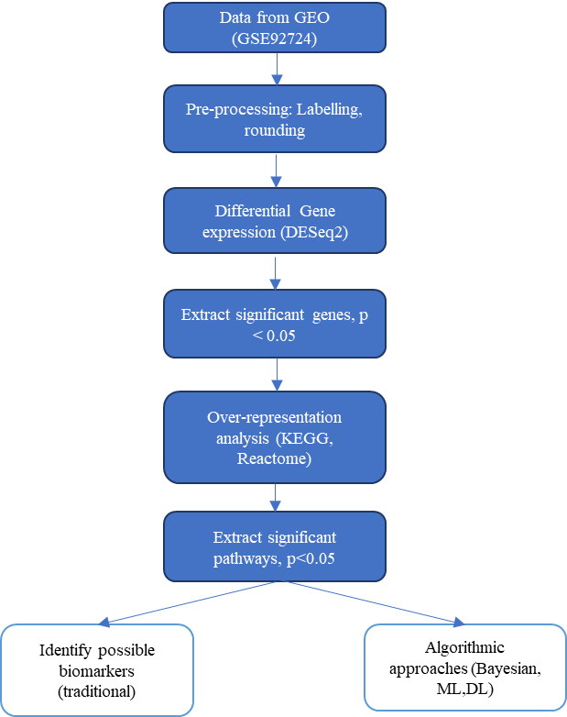

**3. Results**

**3.1 Differential Gene Expression**

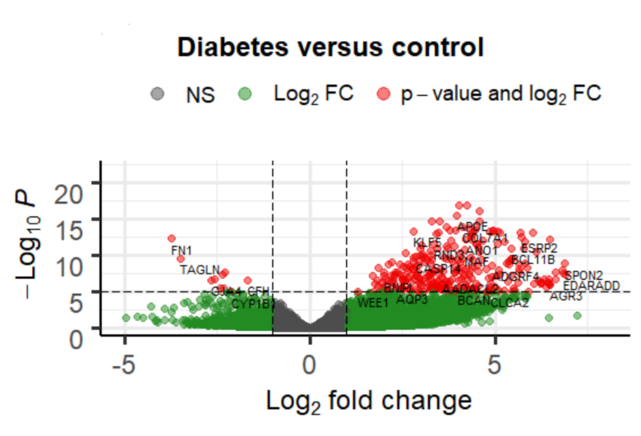

**Fig 1.** Volcano plot (Red genes are significanty expressed)

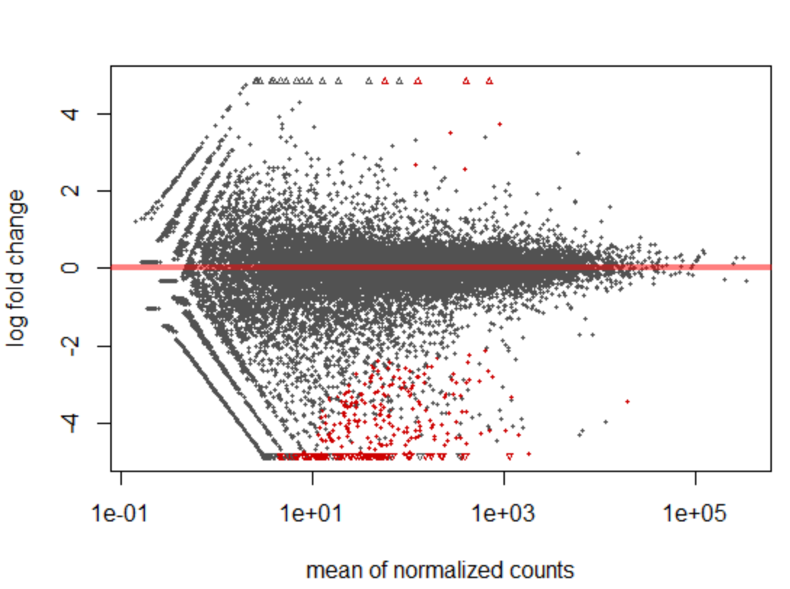

**Fig 2.** MA plot (Red genes are significantly expressed)

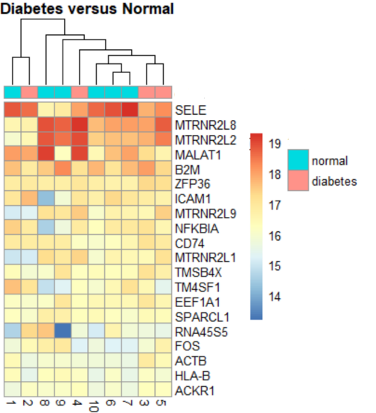

**Fig 3.** Heatmap of top 20 differentially expresed genes

**3.2 Over-representation analysis**

**Table 1.** Significant pathways from KEGG database (Top 5)

|  |  |  |  |
| --- | --- | --- | --- |
| S.No | Database | Pathway | Genes |
| 1 | KEGG | Cytokine-cytokine receptor interaction | TNFRSF18;IL1RN;TNFRSF19;ACKR3;CCL27;CXCL14;IL17RE;IL20;IL20RA;IL20RB;IL22RA1;BMPR1A;CD4;IL18;CCL20;IL10RA;IL7;LIF;IL1B;TNF |
| 2 | KEGG | Signaling pathways regulating pluripotency of stem cells | DLX5;ISL1;OTX1;ID4;LIF;FGFR2;FGFR3;AXIN2;FZD10;WNT10B;FZD7;WNT16;WNT5B;WNT4;WNT3;BMPR1A |
| 3 | KEGG | Cell adhesion molecules (CAMs) | CDH3;CNTN1;NLGN4Y;NEO1;PVRL1;PTPRF;SDC4;CLDN4;CLDN8;SDC1;CD4;CD86;CLDN1;CDH1;VCAM1;ITGA4 |
| 4 | KEGG | Transcriptional misregulation in cancer | HPGD;PAX3;BCL11B;UTY;SPINT1;ARNT2;MAF;CEBPA;JUP;SPI1;WNT16;CD86 |
| 5 | KEGG | PI3K-Akt signaling pathway | MYB;IL7;LPAR3;NTF3;NTF4;PPP2R2C;LPAR5;THBS2;THBS4;ERBB4;LAMB4;COL4A6;LPAR1;ERBB3;ITGB6;FGF18;FN1;ITGA4;FGFR2;FGFR3;BCL2;PDGFC |

**Table 2.** Significant pathways from REACTOME database (Top 5)

|  |  |  |  |
| --- | --- | --- | --- |
| S.No | Database | Pathway | Genes |
| 1 | REACTOME | Formation of the cornified envelope | CSTA;DSC1;DSC3;PRSS8;SPINK5;PKP3;KLK8;KRT80;EVPL;CASP14;KRT1;KRT10;KRT15;KRT19;KRT31;ST14;PERP;KRT5;KRT14;DSG1;DSG3;PKP1;JUP |
| 2 | REACTOME | Metabolism of amino acids and derivatives | DCT;PHGDH;PSAT1;HAL;PRODH;TYR;TYRP1;BBOX1;CRYM;HAAO;CKB;CKMT1B;ASPA;CKMT1A;FOLH1;FOLH1;GATM;ASPG;DUOX1;MAT1A;SLC7A5 |
| 3 | REACTOME | Signaling by Receptor Tyrosine Kinases | MST1R;NTF3;PDGFC;THBS4;SPINT1;SPINT2;PTPN3;NTF4;TNS4;ESRP2;FGFBP1;THBS2;JUP;NCF2;ESRP1;PTK6;COL27A1;APOE;VAV3;S100B;ERBB3;NRG1;NRG2;ERBB4;FGFR2;FGFR3;FGF18;FN1 |
| 4 | REACTOME | Gap junction assembly | GJB6;GJB4;GJA4;GJB1;GJB3;GJB5;TUBB4A |
| 5 | REACTOME | Creatine metabolism | CKB;CKMT1B;GATM;CKMT1A |

**3.3 Cellular response to hypoxia versus insulin resistance**

The differentially expressed genes obtained from 3.1 were analysed to see if any of the genes were involved in cellular response to hypoxia. After the analysis using the Gene Ontology (GO) database, the following genes were determined to be differentially expressed in diabetes and involved in tissue hypoxia. In total, 12 genes were obtained.

**Table 3.** Differentially expressed genes in insulin resistance involved in cellular response to hypoxia (First 5)

|  |  |  |  |
| --- | --- | --- | --- |
| S.No | Gene | Description | Function of interest |
| 1 | ADAM8 | Disintegrin and metalloproteinase domain-containing protein 8 | cellular response to hypoxia |
| 2 | AQP3 | Aquaporin-3 | cellular response to oxygen-glucose deprivation |
| 3 | ARNT2 | Aryl hydrocarbon receptor nuclear translocator 2 | response to hypoxia |
| 4 | BCL2 | Bcl2-associated agonist of cell death | cellular response to hypoxia |
| 5 | CRYAB | Alpha-crystallin B chain | response to hypoxia |